**Ghanaian Household Electrical consumption**

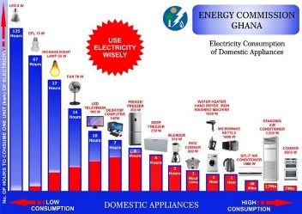

**TV consumption per day**

100w = 10hr

X = 24

10hrx =24×100 = 2400/10

=240 watts/day

**Electric Bulb**

15w = 67

X =24hr

15 × 24 = 67

360/67

5.4 watts/ day

If this case we take into consideration the number of light bulbs a household may have. Let assume each household have 15 bulbs the wattage will be equal to 5.4× 15 which will give us 81 watts. But most bulbs are only on for are on for only 12 hours a day so the wattage will be equal to 81/2 which will give us 40.5. Two was used as the denominators because 12hr equals half a day.

**Fridge**

200w= 5hr

X = 24hr

4800/5

=960 watts/day

1000w= 60 minutes

X= 0.5

500/60

=8.3watts in 30minutes

It was done in 30minutes because is not on all the time so my estimated time was 30minutes.

**Blender**

310= 3hr

310 = 180minutes

X = 30 minutes

310×30

9300/180

=51.7watts in 30minutes

**Air conditioner**

1500 = 40minutes

X =1440 minutes

1500×1440/40

54,000 watts/day

**Fan**

70w = 14 hours

X =24

1680/14

120 watts/ day

**Common house hold appliances**

|  |  |
| --- | --- |
| Appliance | Consumption in watts |
| Tv | 240 |
| Radio | 120 |
| Fridge | 960 |
| Blender | 51.7 |
| Electric Bulb | 40.5 |
| Iron | 8.3 |
| Fan | 120 |
| Total | 1,540.5 |

NB: This is without air conditioner.

With the above information gathered we can assume that the total energy consumed in various household in Ghana is around 2,000 watts.

**NUMBER OF PANELS NEEDED AND COST**

Various types of panels on the market and their cost

|  |  |  |
| --- | --- | --- |
| Wattage | In south African Rand | In Ghana Cedis |
| 400 | 2,323.00 | 720.13 |
| 410 | 2,333.93 | 723.52 |
| 310 | 1,711.20 | 530.47 |

**NB: 1 South African rand is equal to 0. 31 Ghana cedis.**

So if one panel gives us 400 watts

1 = 400 watts

X = 2000

2,000/400

= 5 panels per house (taking into consideration the information given above. The number of panels can change if the number of appliances are more than one).

2,000 equals consumption rate of one household in a day.

So the cost of a household can be estimated to number of panels multiply by the cost of a panel.

5 X 723.52 cedis

= GH₵ 3, 617.6 per household taking into consideration if there is only one of each appliance in the household.